**Appendix 2 – document analysis.**

**Document 1 – Order sheet 1.**

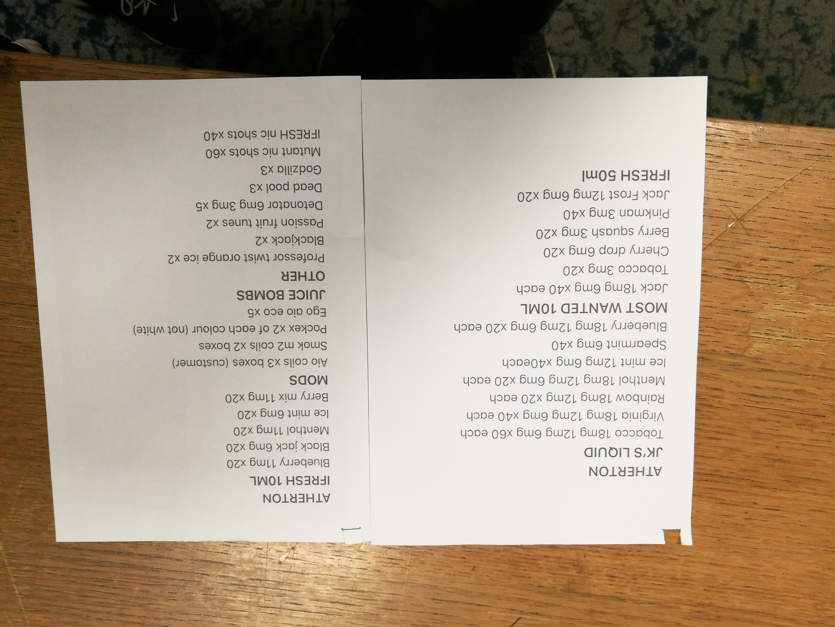

This is one of the order sheets that was received in the main shop, it looks like it was written on Microsoft word.

|  |  |
| --- | --- |
| FIELD | FIELD DESCRIPTION |
| JK`s Liquid / Most Wanted 10Ml / IFresh 50Ml / IFresh 10Ml / Mods / Juice bombs / other | These are product groups, this tells the shop which section they are going to be found in, it also helps as sometimes there are the same flavour names in two different sections, such as Jks strawberry and Most wanted strawberry. |
| Tobacco / Virginia / Menthol / Ice Mint etc | These are product names. These are generally the flavour of the liquid in the JKs section and in Ifresh but in other sections they have really creative names that the manufacturers have given them, such as Pinkman, which is like a berry mix. This is how the product is identified |
| 18mg / 12mg / 6mg / 3mg / 0mg | These are the nicotine strength of the liquid, this is basically how strong the nicotine is in the liquid. The 18mg is the strongest and 0mg is the weakest. The flavour strength doesn’t often follow this trend, but it does sometimes. |
| X20 / x40 etc | This is the amount of the product that the shop is ordering from the main shop. |

There are titles for the different products that are to be ordered, but there is no table layout. The lack of a table layout does make it hard to do it quickly as you have to look for the strength of the liquid and then look again for the amount of them. This will take more time than it should do, and will cause the staff doing the orders to not work as fast as they should be able to. And because of this some of the jobs in the shop might not get done.

The liquids that are listed are not even in alphabetical order, this could cause quite a bit of confusion as it would be so much easier to read off which liquids are needed as they come in the alphabet and also how they are stored on the shelves. This could save time as the employee could grab the other liquids that are located near each other as they are collecting the other liquid. I know that when they do orders it is always a big rush to do and all of these little inconsistencies do add up and can cause the order not to be done in time, which can impact sales.

In this order there are blank sections of the order sheet, this can cause confusion whether there is supposed to be something in that category or not, as you can see, where it says “JUICE BOMBS” and then right underneath it there is “OTHER”. Staff could be unsure whether the juice bombs are to be put into the order or not, and the order may be just referencing to give some of the juice bombs as discusses, but if this is the case, it should have been added to the order properly.

Overall this document would be a lot more efficient if it was a table of data a bit like:

|  |  |  |
| --- | --- | --- |
| PRODUCT NAME | STRENGTH mg | QUANTITIY |
| BlueBerry | 18 | / | 12 | / | 6 | / | 3 | | | 20 each |

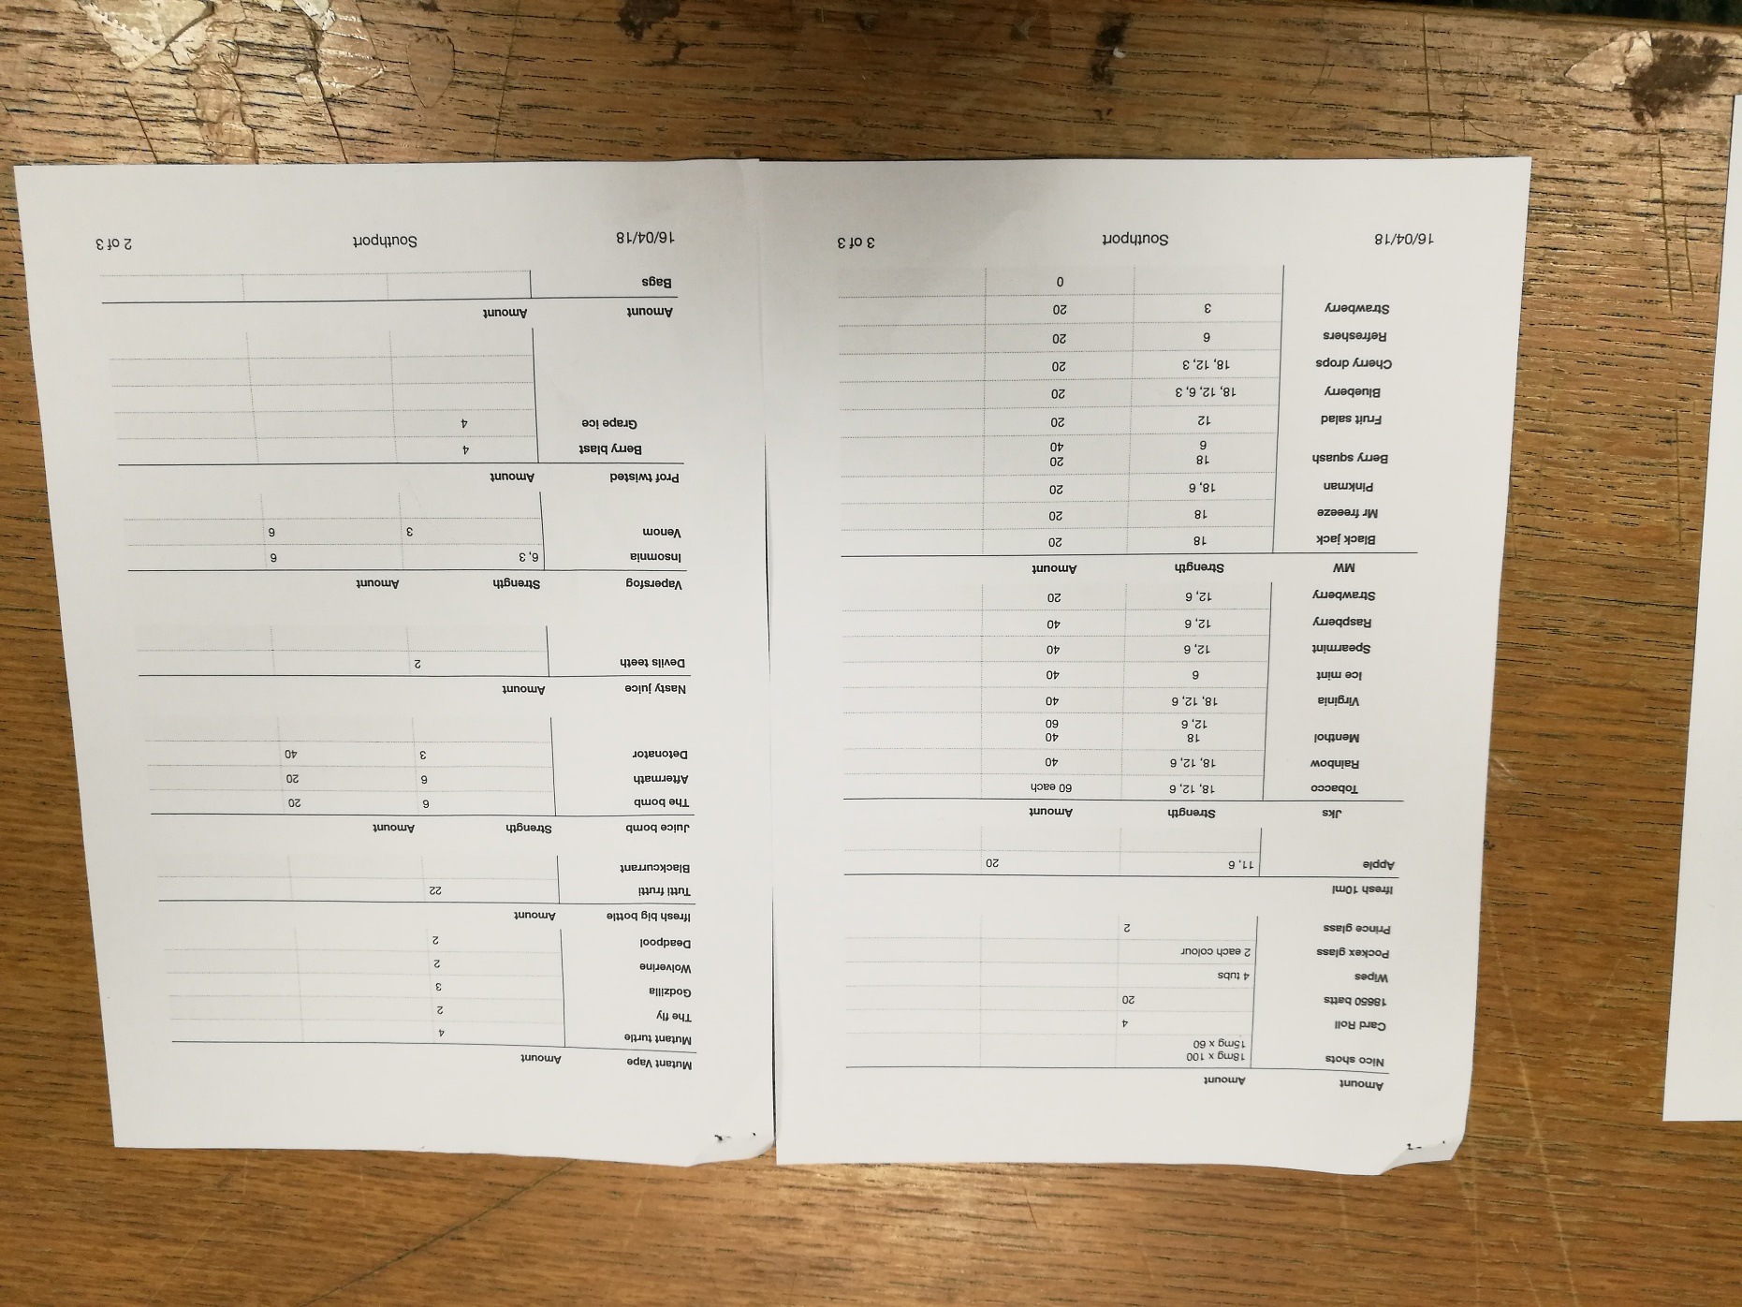Document 2 – Order sheet 2

This is a much better layout for an order sheet.

|  |  |
| --- | --- |
| FIELD | DESCRIPTION |
| JKS / MW / Ifresh big bottle / nasty juice etc | This is the product group, this makes it easier to find the products and also to collect multiple products at once, as in the back room where the products are stored they are categorised, this is to make the products easier to find. This is what is being referenced here. It also helps to distinguish the same names such as Jks Strawberry and Most wanted strawberry |
| Strength | This is the strength of the nicotine in the liquid that is being ordered. As the shop does a variety:  18mg 12mg 6mg 3mg 0mg. the flavour strength doesn’t normally follow this trend, but sometimes it does.  Sometimes this column isn’t in the table, this is because it only applies to the liquids and not the coils |
| Amount | This is the amount of the product that is being ordered |

As you can see there is a little bit of a type at the top, “Amount” is the name for both of the columns, this might be confusing, but this would probably be ignored as they are rushing that much when orders are due to be done. That first column should be named “other” or “Mysc”.

This document will be much easier to follow as it is in table form, and the columns do make sense and are consistent throughout the whole document. The document is a paper copy, but there is a digital copy. The document is ticked when the products that are ordered are put into the box, then the order sheet is binned. This order sheet could be made electronic and be filled in on the computer and so the shop can find out what stock they have coming and which stock they need to wait a bit longer to get back in. this would stop the shop staff from telling customers that they will have a certain product in on a certain date and then not receiving it in an order. This could lead to the shop losing a customer and this might decrease the profit that the shop is making.

At a glance I can see exactly how much of each product the shop wants. One issue with this document is that the products are not in alphabetical order, if they were it would make products easier to find in the hard copy of the order. Another way to make products easier to find how much is needed of them would be to make the orders electronic, so that the staff can search the order for products.

Overall, the two documents show inconsistencies amongst the shops, which can cause confusion. One is better laid out than the other, as it has tables with relevant columns for data. Even though none of them are in alphabetical order. Being in alphabetical order would help as the products would be easier to scan through and find.